Alabama Chapter of Partners in Amphibian and Reptile Conservation

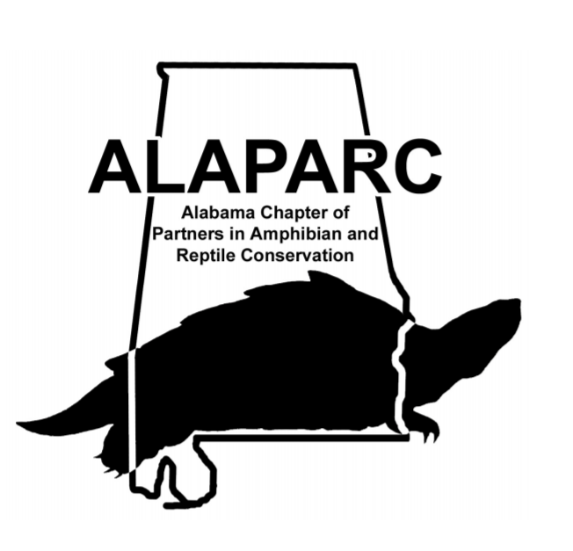9th Annual Meeting
October 19th-21st 2018
Dauphin Island Sea Lab, Dauphin Island, AL
About Our Meeting

Welcome to the ninth annual meeting of the Alabama Chapter of Partners in Amphibian and Reptile Conservation (ALAPARC) at the Dauphin Island Sea Lab (DISL), Dauphin Island, Alabama. Maps of the Sea Lab are provided at the back of this program. All talks will occur in the Shelby Fisheries Center and all meals will be served in the Cafeteria. The poster session and socials will also occur in Shelby Fisheries Center.

Dauphin Island Sea Lab

Accommodations
Upon arrival, check in at the Shelby Center where we will have your room assignments and keys. Rooms will be in the Challenger Dormitory. Please leave the doors unlocked when you leave the DISL. Use the campus map (provided at the back of this program) to locate the different buildings. There is NO bedding or toiletries provided by the DISL. You must provide your own bed linens or sleeping bag, pillow, towels, and toiletries.

Meals
All meals will be served in the Cafeteria. Try to make it to the Cafeteria in a timely manner at the assigned times.

Sustainability
Please consider bringing your own coffee mugs and beer steins to our meeting so that use of disposable cups will be minimized. Containers for recycling aluminum cans are located throughout the campus. We will also be recycling or reusing any glass bottles.

SCHEDULE

Friday October 19th
Time Event

2:00-4:30 Field Outing to Cedar Point Marsh (Meet at Shelby Center) Jimmy Stiles
4:30 Check-in (Shelby Center)
5:00 Dinner
6:30 Introduction
6:30-6:50 An Update on Conservation Initiatives, Policies, and Growth of Southeast Partners in Amphibian and Reptile Conservation (SEPARC). Andrew W. Cantrell
6:50-7:10 Discussion of the Role and Future of ALAPARC: Advantages and Disadvantages of Incorporating as a Nonprofit. A. Joseph Jenkins

7:30 Poster Session/Social

Saturday October 20th
Time Event
7:00 Breakfast
8:00-8:20 Population demographics of an invasive lizard following experimental introduction on small islands. Amelie Fargevieille
8:20-8:40 Surveying Historic Sites and Identifying Focus Areas for Conservation of Flattened Musk Turtles (Sternotherus depressus) in Locust Fork of the Black Warrior River, Alabama. A. Joseph Jenkins
8:40-9:00 Using geometric morphometric analysis to test species hypotheses for southeastern kingsnakes (Lampropeltis getula complex). Iwo P. Gross
9:00-9:20 Recent extinction of an invasive lizard population in Alabama. Daniel A. Warner

9:20-9:30 Break
9:30-9:50 What is a Salamander: Results of One Word Surveys to Gauge View on Herps. Andrew W. Cantrell
9:50-10:10 Long-term patterns of abundance of Gopher Tortoises on the Conecuh National Forest. Craig Guyer
10:10-10:30 Update on long term herpetofaunal community response to silviculture treatments at William B Bankhead National Forest, Alabama. TJ Haltigan
11:00 Lunch
12:00-1:30 A Primer on How to Safely Handle Venomous Snakes. Jimmy Stiles and Raymond Corey
1:30-4:30 Field Outing on Dauphin Island A. Joseph Jenkins
5:00 Dinner
6:00-6:20 Chiggers infecting amphibians– Who knew? – A review. Kristin A. Bakkegard
6:20-6:40 Do Aggregated Populations of Gopher Tortoises (Gopherus polyphemus) Remain Socially Isolated Following Translocation? Philip A. Schulte
6:40-7:00 ALAPARC Housekeeping: Next Year’s Meeting and Selecting the Next Co-Chair. A. Joseph Jenkins
7:00 Poster Viewing/Social
8:00 Auction Benefitting ALAPARC

Sunday October 21st
Time Event

7:00 Breakfast
8:30 Check Out

Abstracts
*presenter
Oral Presentations
Amelie Fargevieille* (akf0020@auburn.edu), Department of Biological Sciences, Auburn University, Auburn, AL; Aaron M. Reedy, Department of Biology, University of Virginia, Charlottesville, VA; Timothy S. Mitchell, Department of Biological Sciences, Auburn University; Andrew M. Durso, Department of Biology, Utah State University, Logan, UT; David M. Delaney, Department of Biology, University of Alabama at Birmingham, Birmingham, AL; Phillip R. Pearson, Department of Biological Sciences, Auburn University; Daniel A. Warner, Department of Biological Sciences, Auburn University. Population demographics of an invasive lizard following experimental introduction on small islands.
Human activities have increased the number of species introductions into non-native ranges. After introduction, some populations grow rapidly in new environments and can affect local biota. We were interested in describing patterns of population demographics during the colonization and establishment stages following the introduction of a non-native lizard species (Anolis sagrei). We released adult lizards onto three small islands prior to the reproductive season and monitored their survival and reproduction over the first reproductive season. Subsequently, to gain insight into the establishment of these introduced populations, we examined the survival and reproduction of the descendants of the founding populations over the following two years. We found variation among islands for survival and reproductive rates of founders, which affected the patterns of juvenile and adult recruitment at a local scale. We also found variation across seasons in survival rate, with different patterns among islands. Our results demonstrate that survival and reproductive rates can vary at local scales affecting the ability of this species to colonize new environments. This fine-scale variation in survival and reproductive rate across islands has important implications for the likelihood of population establishment after colonization.

A. Joseph Jenkins* (ajj0012@auburn.edu) and James C. Godwin, Department of Biological Sciences, Auburn University, Auburn, Alabama. Surveying Historic Sites and Identifying Focus Areas for Conservation of Flattened Musk Turtles (Sternotherus depressus) in Locust Fork of the Black Warrior River, Alabama.
The Flattened Musk Turtle (Sternotherus depressus) is a small kinosternid turtle endemic to the Upper Black Warrior River Basin (BWR) of Alabama. Severe range-wide declines attributed to sedimentation and chemical pollution from mining, agriculture, and development have been observed over the past few decades. In response to this decline, S. depressus was listed as threatened under the Endangered Species Act in 1987 and is considered critically endangered by the International Union for the Conservation of Nature. Despite listing, declines have continued, and trapping surveys indicate the species may now be at imminent risk of extirpation from over 90% of its historic range. In this study, we map stream substrate using side-scan sonar and conduct intensive wading surveys on the Locust Fork Watershed of the BWR to identify areas with suitable habitat structure and locate surviving populations where trapping surveys have failed. We present results from wading surveys and discuss plans for utilizing sonar habitat data to inform future recovery efforts.

Iwo P. Gross* (ipg0004@auburn.edu) and Brian Folt, Auburn University. Using geometric morphometric analysis to test species hypotheses for southeastern kingsnakes (Lampropeltis getula complex).
The process of species delimitation continues to benefit from the inclusion of morphological analyses to diagnose species and test hypotheses using an integrative taxonomic framework. In this study, we sought to test whether three recently described species of kingsnakes in southeastern North America (Lampropeltis getula, Lampropeltis meansi, and Lampropeltis floridana) are morphologically diagnosable using a shape-based morphological analysis, geometric morphometrics. We analyzed the lateral head shape and scalation patterns of kingsnakes (N = 78 specimens) with photographs based on covariation in the positions of 44 anatomical landmarks. Principal component and canonical variate analyses found wide overlap in geometric patterns across all specimens and a low discriminatory power of a priori species groupings. Our results indicated a lack of shape-based morphological divergence among kingsnakes, which we view as a line of evidence suggesting they may be conspecific. Given that there are no clear biogeographic barriers between putative kingsnake taxa, the populations appear to contain large hybrid zones between taxa, and previous applications of geometric morphometrics for snakes have been powerful for delimiting species, we suggest that a taxonomic re-appraisal of the Lampropeltis getula complex is needed.

Daniel A. Warner* (daw0036@auburn.edu), Joshua M. Hall, Austin Hulbert, Sarin Tiatragul, Jenna Pruett, and Timothy S. Mitchell, Department of Biological Sciences, Auburn University. Recent extinction of an invasive lizard population in Alabama.
Human activity is responsible for numerous introductions of species to areas outside of native ranges. However, because many introduced populations may not persist long enough to be noticed, and hence remain unreported, the factors responsible for population establishment or extinction are often difficult to quantify. We studied a viable population of brown anoles (Anolis sagrei; native to Cuba and The Bahamas) at a temperate latitude that is farther north than its continuous invasive range in the southeast United States. This population was first reported in 2006 at a commercial greenhouse near Auburn, Alabama and likely arrived via propagules transplanted in ornamental plants. The warm confines of the greenhouse presumably buffered this population from lethally low winter temperatures and has allowed the population to persist for at least 12 years/generations. However, the greenhouse rapidly degraded after the facility went out of business (in 2016) and lost its roof due strong winds from Hurricane Irma (in 2017). Prior to winter 2017, individuals of both sexes and all age classes were present (from eggs to adults), and the population size was at least 260 individuals. Post-winter surveys in 2018 revealed that no A. sagrei survived winter. Without the thermal buffering of the greenhouse roof, temperatures dropped well below the population’s CTmin, and individuals were presumably exposed to lethally low temperatures. This study provides a rare documentation of an extinction of a viable introduced population and illustrates the role that anthropogenic structures and natural weather events play in population establishment and extinction.

Andrew W. Cantrell* (andrew.w.cantrell@gmail.com), Alabama A&M University. What is a Salamander: Results of One Word Surveys to Gauge View on Herps.
Educational outreach is a major part of conservation. To better our efforts of where educational efforts should be made, it may be beneficial to evaluate how people feel about herps in the first place. Before a series of educational outreach events I gave one-word surveys, in which I would ask those taking the survey to give the first answer that came to mind when given the following terms: Reptile, Amphibian, Frog, Salamander, Lizard, Turtle, and Snake. I also asked if there was a particular one that was their favorite and if there was one they did not like. This questionnaire was designed to be easy and for all ages. Though the sample size was small, and likely somewhat biased because these were done during educational outreach events, some trends did stand out. Turtles rank high as favorites amongst both children and adults. Snakes were probably the least liked, though this was more likely the case with adults. Many of the answers were expected, such as people think of a shell when asked turtle, hopping when asked frog, and slithering when asked snake, however most people either did not give a response for salamander or simply put lizard, and sometimes even reptile. This suggests that across all species, education on salamanders is lacking and we as educators should find ways to develop ways to better incorporate them into outreach events.
Jeff Goessling, Biology, Eckerd College, St Petersburg, FL and Craig Guyer*, Department of Biological Sciences, Auburn University, Auburn, AL. Long-term patterns of abundance of Gopher Tortoises on the Conecuh National Forest.

We performed a mark-recapture study of Gopher Tortoises on three sites on the Conecuh National Forest of southcentral Alabama. Starting in 1991, tortoises were captured in wire live traps, measured for body size, marked with file marks along the marginal scutes, and released to the burrows from which they were captured. Age of each individual was estimated from counts of annuli on plastral scutes. From 1991-1998 all three sites were sampled on a near-annual basis. From 1999-2003 additional annual samples were taken for one site. All sites were resampled twice between 2013 and 2017. Program MARK was used to estimate patterns of survival and abundance on each site. Survival of tortoises was similar across all three sites and did not differ among size/age classes. Our data indicate 90% survival from one sample to the next, even for the smallest individuals. On two sites, populations of 20-30 individuals were present across the 25-year period of study. For the third study site abundance doubled from about 30 individuals to about 60 individuals. However, migration of individuals on to and off of each site likely occurred, yielding estimates of 70-173 individuals in the superpopulation occupying the sites. Our data provide novel insights into population stability of Gopher Tortoises at the northern periphery of the geographic range of the species.

TJ Haltigan* (tjhaltigan@gmail.com), Alabama A&M University, Department of Natural Resources and Environmental Sciences, Normal, AL; Yong Wang, Alabama A&M University, Department of Natural Resources and Environmental Sciences; and William Sutton, Tennessee State University, Department of Agricultural and Environmental Sciences, Nashville, TN. Update on long term herpetofaunal community response to silviculture treatments at William B Bankhead National Forest, Alabama.
Understanding the impacts of forest management techniques on wildlife habitat and community composition is essential for long-term biological conservation. As part of an ongoing long-term research project evaluating the effects of prescribed fire and thinning regimes on herpetofaunal communities using a field experiment consisting of control impact and factorial complete block design from 2005 to 2017, we sampled herpetofauna from May to October. Throughout the sampling period, we collected 861 individuals representing 34 species (15 amphibians and 19 reptiles) during 984 trap nights. One-way anova tests were conducted in order to compare both average species richness and average species diversity across each treatment. Neither Species richness nor species diversity were found to be significantly different among silviculture treatments. The impact of these treatments must be continuously studied in order to understand the long-term effects of forest management. Tissue samples from all captured animals are being collected for future analysis of the potential impacts of altered microhabitat characteristics on genetic variation among silviculture treatments.

Kristin A. Bakkegard* (kbakkega@samford.edu), Samford University. Chiggers infecting amphibians– Who knew? – A review.

Chiggers are the parasitic larval form of mites which infect a variety of terrestrial vertebrates. In amphibians, chiggers burrow in and under the skin and have the potential of harming the infected animal through mechanical damage to skin and toes or by introducing a pathogen. Chiggers infecting amphibians is complex - chiggers are small and difficult to identify, taxonomic keys and species descriptions are unclear for both Hannemania (an amphibian specialist) and Eutrombicula (a generalist), the two genera infecting amphibians in North America. It is not even settled as to how many species of Hannemania (anywhere from 9 to 11 in North America, up to 25 species total including those found in South America & New Caledonia) or Eutrombicula there are. Synonymy is common in Hannemania and Eutrombicula cinnabaris (alfreddugési) may be a species complex. In response to finding Northern slimy Salamanders (Plethodon glutinosus) in north-central Alabama infected by Hannemania c.f. dunni, I conducted a literature review on amphibians infected with chiggers in North America. I found 302 records in 81 peer-reviewed papers with state-level locality data. Chigger infected amphibians were recorded in 20 of 50 states, mainly across the southern half of the United States. Those states with the most records have a resident parasitologist or a natural history museum that did/does significant parasitology research. Of the literature records, only 15% were in herpetology themed journals, whereas almost 60% of publications were in parasitology, entomology, or regional natural history journals. I recommend that reports and research into chigger infected amphibians, be, as oft is practicable, published in the herpetological literature to improve awareness and encourage further research into the contribution of chiggers and other multicellular parasites to amphibian decline.

Philip A. Schulte* and Sharon M. Hermann, Department of Biological Sciences, Auburn University, Auburn, AL. Do Aggregated Populations of Gopher Tortoises (Gopherus polyphemus) Remain Socially Isolated Following Translocation?

The gopher tortoise (Gopherus polyphemus) is one of the most commonly translocated reptile species (Dodd and Siegel, 1991). In Florida, these translocations often aggregate multiple populations of gopher tortoises in long-term protected sites. For a wide range of species, translocation success is often measured in terms of site-fidelity following release of animals, and this aspect of the practice has been followed for gopher tortoises. However, Guyer et al. (2014) reported that a native, intact population of gopher tortoises may exhibit an extensive social network. This network is defined by interconnected subunits of the population the authors termed “cliques”. Behavioral responses to a disruption of the social network in gopher tortoise populations has not been reported previously. Because translocation of gopher tortoises is likely to continue in the face of urban development, it is important to determine if aggregated populations form novel social networks. It is possible that multiple populations of gopher tortoises being held within the same translocation pen could remain socially isolated from each other. To test that hypothesis, we tracked the movements of 61 Incidental Take Permit (ITP) gopher tortoises translocated to Nokuse Plantation in Walton Co., FL from June – September 2017. Tortoises came from seven source populations from six Florida counties and were released into a single holding pen. Movements were tracked via radio telemetry and burrow scoping 4-7 days/week and burrow use was recorded for individual. Burrow shares (two individuals in a single burrow at the same time) and burrow chases (one tortoise occupying a burrow previously occupied by another individual within 24 hours) were recorded (Johnson et al., 2009). Burrow shares and chases were used to construct an individual x individual matrix, which was then analyzed using the methods and Girvan and Newman (2002) to determine social network structure. Preliminary analysis suggests that source populations do not remain socially isolated from one another within the same translocation pen.

Posters
Brent C. Newman, Tennessee State University, Department of Agricultural and Environmental Sciences, Nashville, TN; William B. Sutton, Tennessee State University, Department of Agricultural and Environmental Sciences; TJ Haltigan* (tjhaltigan@gmail.com), Alabama A&M University, Department of Natural Resources and Environmental Sciences, Normal, AL and Yong Wang, Alabama A&M University, Department of Natural Resources and Environmental Sciences. A survey of ticks (Acari: Ixodida) parasitizing reptiles from managed pine-hardwood forests of northwestern Alabama, USA.

Reptiles and amphibians were trapped and examined for ticks from May through August 2017 in 18 total forest stands treated with a variety of management treatments, including two levels of prescribed burning and three levels of thinning in the William B. Bankhead National Forest located in northwestern Alabama. Two tick species (Ixodes scapularis and Amblyomma americanum) were collected from six species of lizards (Plestiodon fasciatus, Plestiodon laticeps, Plestiodon inexpectatus, Anolis carolinensis, Sceloporus undulatus, and Scincella lateralis). Lizards parasitized by ticks occurred at all treatment sites, however, lizards parasitized by ticks were most abundant in prescribed burning and thin with prescribed burning treatments. Ticks were most commonly encountered on Plestiodon fasciatus and Plestiodon laticeps with peak infestations occurring in July. Our results indicate that lizards may play an important role in the life cycle of ticks of which forest management techniques may also influence this parasite-host relationship.

S. Gardner, Auburn University; V.R. Assis, University of Sao Paulo; Miles Horne*, Auburn University; and Mary T. Mendonça, Auburn University. Evaluating toxicity of Florida cane toads: gland sizes and poison secretion.
Invasive species can harm native fauna through competition and predation, and toxic invaders can poison native predators. Cane toads, introduced to several locations around the world, have been reported with larger paratoid (poison) glands near the invading front in Australia, indicating higher risk to naïve predators. To assess relative toxicity of Florida cane toads in terms of gland sizes and likelihood of secreting poison, approximately 20 toads per population were captured and placed into plastic bags from 9 Florida populations. Following one hour of capture, toads were removed from the bags and mass, sex, and snout-vent-length (SVL) were recorded. Toads were placed next to a ruler and images were obtained to measure gland sizes, with images also showing if a toad was secreting poison following this handling period. Measurements of total length, width, and area of glands were performed using Image J software. An ANCOVA using the first component of a principal component analysis (“small gland size”) of Log-transformed gland length, width, and area, was used to explain morphological differences among Florida toads. Gland sizes increased with increasing body mass (p = 0.019), although they were not significantly affected by latitude. Using a generalized linear model to assess likelihood of poison secretion, toads were twice as likely to secrete following capture and handling with every degree of increasing latitude (p = 0.038). Although gland sizes of Florida toads didn’t significantly change with latitude, the likelihood of toads secreting poison as distance from the introduction point increases in Florida is similar to Australian cane toads, and may indicate relative toxicity increases with increased dispersal.

Robin B. Lloyd Jr.* (rl1724@jagmail.southalabama.edu) and Adam D. Chupp, University of South Alabama. Persistence and population dynamics of Gopher Tortoises (Gopherus polyphemus) in Southwest Alabama.

Recent trends illustrate a range-wide decline in populations of Gopherus polyphemus, a species of tortoise endemic to the southeastern United States. G. polyphemus is a keystone species promoting species biodiversity by the engineering of burrows in longleaf pine sandhill communities along the Gulf Coastal Plain. In Alabama, the species has been issued federal protection west of the Mobile and Tombigbee River, while it receives state protection across its entire range in Alabama. The eastern boundary of Mobile County represents a transition zone between federally protected and unprotected lands. In this study, we compared current population dynamics to those generated from historical surveys of the same sites in 1991-1993. We also compared differences between federally protected (Mobile County) and unprotected (Baldwin County) populations. Our preliminary findings suggest that the population dynamics have changed very little in the past 25 years in Mobile County. This is an ongoing project, with surveys for Baldwin County (state only protected land) still in the works. However, evidence suggests Baldwin County has experienced significant decline in populations since 1990.

Sara E. Piccolomini* (sep0036@auburn.edu), Auburn University; Mary Mendonca, Auburn University; David A. Steen, Auburn University; and Lora L. Smith, Joseph W. Jones Ecological Research Center. Evaluation of post-release movement and habitat selection behavior in reintroduced populations of the Eastern Indigo Snake (Drymarchon couperi).

In an attempt to combat against defaunation, species repatriation is becoming an increasingly popular management strategy which aims to establish self-sufficient populations in areas throughout a species range where extirpation has occurred. Monitoring movement patterns of reintroduced individuals following their release into the wild provides insight on survival rates, habitat selection and space use. When dispersal patterns of reintroduced individuals suggest fidelity to release sites, it can be an early indication of reintroduction success. The Eastern Indigo Snake (Drymarchon couperi) is a federally threatened colubrid endemic to the southeastern U.S. for which two reintroduction efforts are currently ongoing in Conecuh National Forest (CNF), Alabama and at Apalachicola Bluffs and Ravines Preserve (ABRP), Florida. This study aims to (1) quantify home-range size and dispersal patterns of ABRP reintroduced D. couperi at multiple spatial and temporal scales and (2) inform future reintroduction efforts of post-release movement patterns and space use exhibited by reintroduced D. couperi. ​

Sarin Tiatragul* (stiatragul@auburn.edu), Joshua Hall, and Daniel Warner; Department of Biological Sciences, Auburn University. Anole nesting behavior enhances egg survival in urban areas.
Anoles occupy diverse habitats around the world from dense forests to arid islands, which pose different challenges for nesting females because embryo development is directly affected by nest microhabitats. For anoles that occupy urban environments, the nesting situation for females is exacerbated as ground temperature can extend beyond tolerable limits for developing embryos. Despite this, many species have established populations in urban areas outside their native ranges and habitats. Without physiological adaptations of embryos to markedly hotter conditions, maternally-selected nest sites may facilitate embryonic survival. In Puerto Rican crested anoles (Anolis/Ctenonotus cristatellus) from an urban area in Miami, mothers’ nest in microhabitats that are, on average, cooler than microhabitats that are not used for nesting. To test the hypothesis that mothers choose sites with thermal environments that facilitate egg survival, we incubated eggs from a captive colony of wild-caught crested anoles from Miami under thermal regimes that mimic 1) maternally-selected nests in urban areas, 2) sites not used for nesting in urban areas, and 3) nests sites in a nearby forest. Our results indicate that thermal regimes of maternally-selected urban nests yield higher egg survival than those of sites that were not used by nesting females. Survival did not differ between urban and forest nest treatments. However, eggs incubated under urban treatments developed faster and hatched earlier than those incubated under forest thermal regimes. Our study revealed that maternal nest sites in urban areas shield embryos from potentially lethal conditions, which contributes to the successful colonization of anoles in Miami.
About Our Chapter
Alabama PARC is co-chaired by Joseph Jenkins and TJ Haltigan and is a chapter within Southeast PARC (SEPARC) co-chaired by Katie Parson and Becca Cozad. For more information about SEPARC visit www.separc.org. ALAPARC’s website is www.alaparc.org. National PARC’s website is www.parcplace.org.

How to get to the Dauphin Island Sea Lab
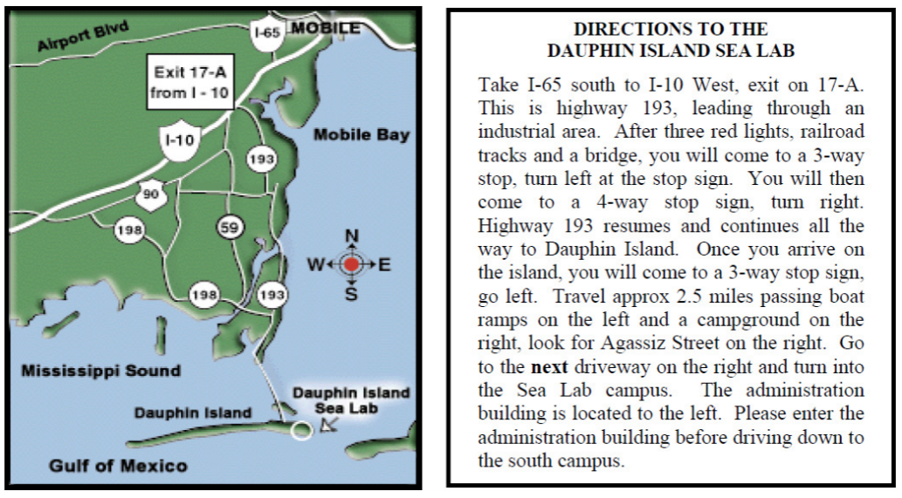

Map of Dauphin Island Sea Lab Campus
